Sunday League
HAYWARD SUNDAY LEAGUE ROUND UP
Sunday 27th September 2020
BIG THREE UP AND RUNNING IN TOP FLIGHT
The DIVISION ONE table has a familiar look to it with Abbey, Loch & Quay, and Talbot Rangers all vying for top spot.
Abbey are in pole position on goal difference after Max Wilcock notched a hat-trick in their 4-1 victory over Bournemouth Athletic. Sam Lanahan was the other Abbey marksman with Brad Connell getting a 70th minute consolation goal for Athletic.
Loch & Quay go second after Luke Delaney and Pepe Smith accounted for Alderney Manor 2-0 while Talbot Rangers complete the leading trio on seven points after a hat-trick from second half substitute Mickey Finch proved decisive in their 5-2 win over AFC East Christchurch. Former Rangers skipper Kieron Arif made a welcome return to the club, scoring their other two goals while Ryan Attree and Richard Sainsbury were the AFC East Christchurch scorers.
A solitary goal was enough to settle the issue in the other Division One game. It came in the 39th minute when East Christchurch SSC’s Max Fletcher embarked on a superb solo run down the left, going past four players, before putting over a cross which was deflected into his own goal by a West Howe defender.

Ollie Bolton netted for early DIVISION TWO pacesetters Bournemouth Sports Mercury but they drop back to third place after AFC Branksome toppled them 2-1 with first half goals from Sam Holland and Alex Corbin.
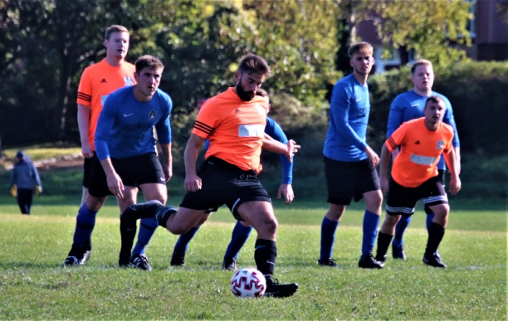
Shoulder of Mutton now lead the table on goal difference from AFC Branksome after subduing Cameron 3-0 with goals from Joe Guerra, Sam Traynor, and substitute Will Gale.
Dan Edwards gave Bearwood Broncos an early lead from the penalty spot but Portchester were soon into their stride with a couple of goals from Kingsley White and a Mark Wood strike. Kingsley White completed his hat-trick just before the interval but Broncos pulled it back to 4-3 after the break with another Dan Edwards strike and a goal from Zac Bond. Portchester responded immediately through Josh Taylor to finish 5-3 winners.
Matthew Chapman-Burnett struck for Vienna Suttoners but AFC Burton got the better of them 3-1 thanks to Aza Khider, Diego Galusni, and substitute Mahmoud Ahi Sbai.
Harry Nash’s hat-trick proved decisive when Wiseguys shaded it 5-4 against NMO. Jordan Gilbert and Shahram Sam-Daliri added one each for Wiseguys while NMO netted through Jake Fields, Matt Hillyar, Tom Prior, and Liam Roberts.
Parkstone lead DIVISION THREE on goal difference after their 5-2 success against Tower Park thanks to Matt Pope, Andy Pugh, Alex Williams, and a couple of goals from Jack Bennett. Ben Collinge and Charlie King were the Tower Park scorers.
AFC Tavern also have maximum points and something’s got to give when they meet Parkstone in a top of the table clash at Branksome Rec this coming Sunday. Martin Sault, Paul Honeybun, and Mark Wheeler ensured a 3-1 win for Tavern against TGC who replied through Harry Grant. TGC finished the game with eight men with Josh Saul, Dan Saul, and Jamie Wilkinson all receiving their marching orders.
Alexander Eaton bagged a hat-trick in Loch & Quay Reserves’ 5-0 drubbing of Iford Park Rangers with Ciaran Quinn and Scott Maidment adding one each while Bransgore United and AFC Wimborne cancelled each other out in a 1-1 draw. Ryan Hamm was the Bransgore marksman with Keiron Alderson replying for the visitors. Bransgore’s Antoine Clark saw red after 90 minutes.
Danny Palmer led the way with a hat-trick when DIVISION FOUR high flyers Kraken Sports walloped Upton Sociedad 8-2. Pete Jones bagged a brace and there were further goals from Aaron Martin, Ocean Smith, and Simon Adair while George Povey and Sam Smithard provided some consolation for Sociedad.
Jordyn Johnston took just two minutes to put Rushmere in front against AJ and they maintained their excellent start to the season with Lascelles Richardson adding two more in their 3-0 victory.
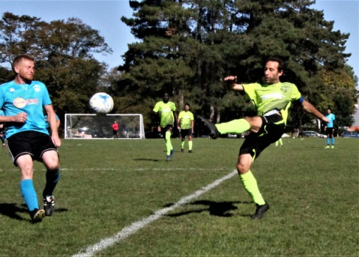
Elliott Davison rattled in seven and substitute Lewis Sainval grabbed a hat-trick when FC Hadjuk crushed Alderney Manor Reserves 14-1 with Jimmy Cooper, Adam Baxter, Andrew Partridge, and Henry Hodge also on target. Damien Mudge was the Alderney scorer.
Winton Athletic led through Jon White and JJ Rayner but, despite being reduced to ten men after Marcus Bartley saw red in the first half, Boscombe Celtic came back after the break with goals from Alex Rossi and Ben Di Verdi to salvage a 2-2 draw.
Branksome Liberal netted through Matt Head and Dan Wills but Kirkfield United had the edge 3-2 courtesy of Danny Mirto, Alan Rossi, and substitute Nathan Edwards.
Meanwhile Scott V were also 3-2 winners when Rhys Huggett’s brace and a goal from Jordan Osmond put paid to Kings Park Rangers.
The leading pair in DIVISION FIVE went head to head and it finished all square 1-1 with Connor Doe’s first half strike for Grange Athletic being cancelled out after the break by Poole Rovers’ Charlie Shears.
Nelson Athletic netted through Lee Burton and Josh Rose but West Howe Rovers just got the better of them 3-2 thanks to Mark Brock, Lewis Cannings, and substitute Lloyd Hemmings.
Connor Picken struck twice for Boscombe Celtic Reserves and Rob Howard added another in their 3-1 win over Parkstone Athletic who replied through Billy Joyce.
Linton Robertson struck for Woodville Wanderers midway through the first half but it was not quite enough to save them from a 2-1 defeat against New Milton Borough whose goals came from George Randall and substitute Josh Yates.
Quayside led 2-1 at half time thanks to Callum Freshwater and Aaron Smith but Longfleet lead DIVISION SIX on goal difference after Stu MacFarlan and a couple of goals from substitute Mihai Voina gave them the verdict 3-2.
Tyler Bloor, Toby Collinge, Rhys Jessop, and Declan O’Donnell gave second placed Hordle Spurs the upper hand 4-2 against AFC Burton Reserves who replied through Luke Harrison and Matthew Lock.
Tom Stephen struck twice in Academy’s 4-2 success against Branksome Liberal Reserves with Billy Bailey and substitute Steve Pender adding one each. Brad Jackson and Callum Rayner were the Branksome scorers.
Shoulder All Stars were also 4-2 winners when Sam Goodwin, Jason Lock, and a couple of goals from Nasim Meddah upended Muscliff Dynamos. Substitute James Stocker scored both Dynamos goals.

