HAYWARD SUNDAY LEAGUE ROUND UP
Sunday 4th October 2020
WARREN OUTSTANDING BUT WEST HOWE BEATEN IN HAMPSHIRE FINAL
Goalkeeper Graham Warren produced an outstanding performance for West Howe when they were beaten 5-2 by a very strong Fawley RSB side in the 2019-20 HAMPSHIRE FA JOHN WARD SUNDAY SENIOR CUP FINAL at Stoneham Lane. Warren, who thoroughly deserved his man of the match award, produced a series of excellent saves to deny Fawley but the Southampton side eventually took the lead on the half hour and added another as the first half drew to a close. Gareth Else revived West Howe’s spirits by reducing the deficit on the stroke of half time, applying the finishing touch to a ball pulled back to the far post. West Howe fashioned a similar goal midway through the second half through Kyle Leach but, by then, Fawley had taken a firm grip of the game with two more goals.
West Howe :- Graham Warren, Liam Whittle, Rhys Evans, Ritchie Whiting, Dan Dominy, Johnny-Ray Porter, Sam Davis, Ryan Marshall, Tommy King, Gareth Else, Kyle Leach. Substitutes:- Ryan Ashford, Tyrone Carkeet, and Adam Louka.

ABBEY GO CLEAR AT THE TOP
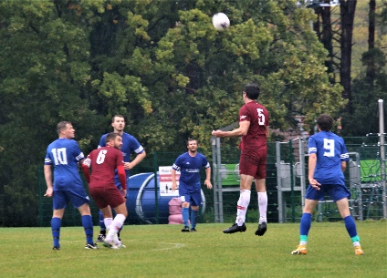
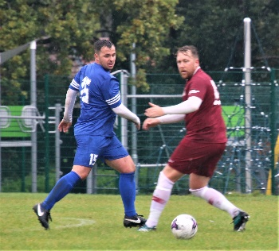
In the only DIVISION ONE game not postponed due to the weather, Abbey opened up a three-point lead at the top of the table with a 6-1 triumph over Alderney Manor. Chris Long and Jamie Moores bagged two each for the league leaders with Mickey Hubbard and Sam Lanahan also on target while Liam Meldrum provided the consolation goal for Manor.
Substitute Andy Masson’s hat-trick gave Shoulder of Mutton the upper hand 4-2 against Wiseguys to open up a three-point lead at the top of DIVISION TWO. Liam Ferguson scored the other goal for the Shoulder while Wiseguys replied through Aaron Staples and Jordan Burgess. Third placed Bournemouth Sports Mercury went down 4-1 to a Matty Chapman-Burnett hat-trick and a goal from Will Foster against Vienna Suttoners while Cameron shaded it 4-3 against NMO courtesy of Kingsly Korang’s hat-trick and a goal from Japeth Buo. Liam Roberts, Liam Lavis, and Callum Boyt were the NMO marksmen.
In the only game to beat the weather in DIVISION THREE, Gary Stevens, Jack Braeman, and Luke Witheford netted for Poole Wanderers but they remain rooted to the bottom of the table after Tower Park sank them 6-3 thanks to Charlie King, Harry Shields, Callum Clayton, Joe Heron, and a couple of goals from Josh Morris.
Kraken Sports have a two-point lead at the top of DIVISION FOUR after they swept Branksome Liberal aside 4-1 through Ocean Smith, Pete Jones, and a couple of goals from Ross Dominey. Matt Head was the Branksome scorer.
Rushmere’s perfect record was ruined by FC Hadjuk who replace them in the runners up spot after upending them 4-1. Rushmere’s leading marksman Lascelles Richardson had mixed fortunes, giving his side a 16th minute lead with a magnificent free kick and then seeing red later in the first half. Hadjuk were already in front by the time Rushmere were reduced to ten men with Elliott Dawson and Lewis Sainval having scored two apiece.
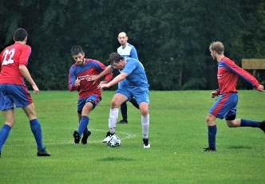
Fourth placed Winton Athletic crashed to a 3-0 defeat against Scott V with Jordan Osmond scoring all three goals while Yusuf Akanni’s hat-trick proved decisive in Alderney Manor Reserves’ 5-2 success against Upton Sociedad. Alderney’s other goals came via Nathaniel Merrett and an own goal while Sociedad replied through Alex Airey and Ben Lees.

Poole Rovers have their noses in front at the top of DIVISION FIVE after Sam Ashford and Charlie Shears gave them the edge 2-1 against Forest United who replied through Oli Sommerfelt.
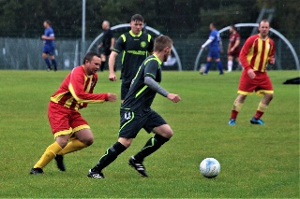
Boscombe Celtic Reserves move up to second place after Rob Howard’s four goal blast put paid to Windgreen Corfe Mullen 7-4. Connor Picken, Alex Rankin, and Carl Phillips added one each for Celtic while Alex Dobson and Steve Morris nabbed two apiece for the visitors.
Meanwhile Rob Scadding and Barnaby Earl scored two each in Woodville Wanderers’ 6-0 drubbing of Nelson Athletic with Aaron Towers and Harvey Waters also on target.

Hordle Spurs go three points clear at the top of DIVISION SIX after Ashley Booker struck twice in their 3-2 success against Academy in the top of the table clash. Dominic Taylor was the other Spurs scorer while Joel Bennett and Justin Brown replied for Academy.
Muscliff Dynamos led 3-1 at half time after netting through James Stocker and a couple of goals from Lewis Wykes but AFC Burton Reserves just got the better of them 4-3 to go second in the table on goal difference with Luke Harrison and Matt Lock bagging two each.
Marc Scrimshaw’s hat-trick was the difference when Shoulder All Stars accounted for Southside Vipers 5-2. All Stars’ other goals came via Sean Eaton and an own goal while Vipers replied through Johnny Armour and Jack Leatherbarrow.
In the other Division Six game Boscombe Celtic “A” were 3-0 winners against Branksome Liberal Reserves thanks to goals from Danny Styles, Danny Hallworth, and Joe Bennett.

Goal from substitutes Josh Furmage (2) and Lewis Hennell eased Quayside through their DORSET SUNDAY CHALLENGE CUP first round tie with Admiral Hardy. Callum Freshwater and Harry Parkinson were the other Quayside scorers in a game which was level 2-2 at half time.

