HAYWARD LEAGUE ROUND UP - SATURDAY 10th and SUNDAY 11th OCTOBER 2020
Saturday League
Saturday 10th October 2020
SPARKIES OVERPOWERED BY MANOR’S THREE GOAL BURST
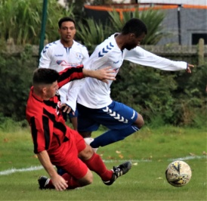
Bournemouth Manor’s three goal second half blitz accounted for Bournemouth Electric 3-1 in the second of the series of M.A. HART PAGE CROFT CUP games.
Electric had the better of the first half and were deservedly in front thanks to Rhys Newman’s 20th minute strike.
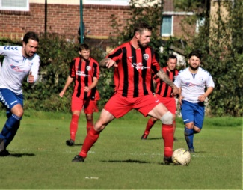
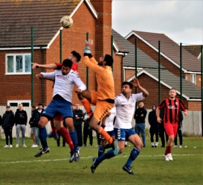
Manor stepped up their game in the second half and Electric’s resistance was eventually broken in the 75th minute when Adam Janes equalised with a header from a corner.
Two minutes later Manor struck again when Terry Foote headed a free kick goalwards and Ed Ewens steered a close range header past the Electric ‘keeper. Barely had the game restarted and Manor scored again through Terry Foote.

In the other Page Croft Cup game, Ringwood Town Development led 2-1 midway through the second half through Frankie Parkinson and Elliott Hemming but substitute Yusuf Akanni came off the bench to score twice in the last 20 minutes to give Ferndown the upper hand 4-2. Edward Bignell and Stephen Mackay were the other Ferndown scorers.

BRATT BLASTS FOUR IN RANGERS RAMPAGE
Twynham Rangers opened their points account in DIVISION ONE when David Bratt let rip with a four goal blast in their 7-2 triumph over Royal Bournemouth. Chris Forbes added a brace for Rangers with Paul Brandreth also on target while Jordan Muir scored both goals for the visitors.
New Milton Eagles also got off the mark when they surprised second placed Winkton Athletic 3-2 thanks to Justin Keeler and a couple of goals from Matt Hillyar. Josh Castro and Connor Mitchell were the Winkton Athletic scorers.
West Howe take over in second place after their 5-1 victory over Fordingbridge Turks. Tommy King struck twice with Darren Else, Luke Scrimshaw, and Kieran Shirley adding one each. Stuart Cromie scored the Fordingbridge consolation goal.

