Sunday League
Sunday 11th October 2020
LOCH & QUAY BANK ON RIVER
DIVISION ONE leaders Abbey were twice ahead through Adam Grange in the first half of their top of the table clash but River Smith put Loch & Quay on terms each time before completing his hat-trick after the break to give Loch & Quay the verdict 3-2.
Talbot Rangers netted through Sami Garcia but East Christchurch SSC replace them in third position in the table after giving them an 8-1 drubbing.
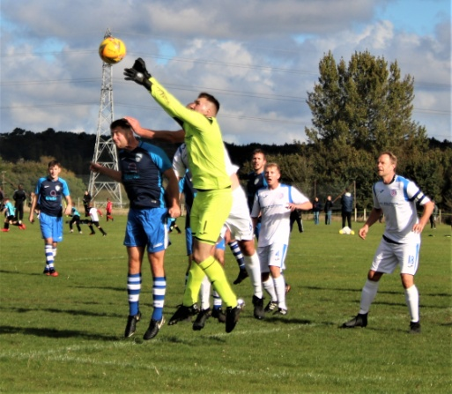
Dave Midgley and Sol Bower bagged two each for East Christchurch with Levi Ridealgh, Alex Whitehouse, and a couple of own goals completing a miserable morning for Rangers.
Meanwhile, at the other end of the table, Bournemouth Athletic went ahead after 30 minutes through Ivan Petrasko but AFC East Christchurch SSC levelled seven minutes later thanks to Conrad Churchill and took all three points when Jake Warry’s 76th minute strike gave them the edge 2-1.
In the other Division One game, Alderney Manor and West Howe cancelled each other out in a 0-0 draw.
Shoulder of Mutton are four points clear at the top of DIVISION TWO after sweeping Bournemouth Sports Mercury aside 4-0. Andy Masson weighed in with a hat-trick for the second week running with Liam Ferguson adding the other one.
Vienna Suttoners move up to second place after Dave Brown and James Bainton clinched a 2-1 win over NMO who replied through Callum Boyt. But, despite scoring through Stuart Marshall, Portchester were beaten 3-1 by Wiseguys courtesy of Aaron Staples and a couple of goals from Danny Harrison-Little.
Meanwhile Cameron netted through Gaber Elfirgani but Bearwood Broncos galloped to a 5-1 victory thanks to Jordan Crossland, Jack Excell, Reece Vincent, Zac Bond, and an own goal.
KNIGHT PUTS VALE TO THE SWORD
Second half substitute Matt Knight kept Parkstone on top of DIVISION THREE on goal difference when his solitary strike five minutes from time clinched a 1-0 win over AFC Stourvale to maintain their perfect record.
AFC Tavern also have maximum points after Shane Barney and Martin Warren bagged two each to subdue Poole Wanderers 5-1. Mark Wheeler was the other Tavern marksman while Jack Braeman scored Wanderers’ consolation goal.
James Palermo’s hat-trick proved decisive when Tower Park emerged 4-2 winners against Bransgore United. Charlie King was the other Tower scorer with Alex Martin and Lucas Walker replying for Bransgore.
Ayrton White struck twice for AFC Wimborne but Poole Borough overpowered them 5-2 thanks to Callum Neate and two goals apiece from Adam Frohlich and Lee Matthews.
Ocean Smith and Aaron Martin netted for Kraken Sports but the DIVISION FOUR pacesetters had their hundred per cent record ruined when Rushmere toppled them 4-2 thanks to Tom Hull, Andy Gosling, and a couple of goals from Jordyn Johnston.
FC Hadjuk are the new leaders after their 3-0 win over Winton Athletic courtesy of Harry Hodge, Lewis Sainval, and Elliott Dawson.
Scott V move up to fourth place after Rhys Huggett and Matt Naylor gave them the edge 2-1 against Boscombe Celtic who replied through Adam Bartlett.
Kirkfield United were also 2-1 winners when Danny Mirto and Jaime Martinez put paid to Alderney Manor Reserves whose goal came from Dean Hayward.
George Povey netted for Upton Sociedad but they went down again when Kings Park Rangers upended them 5-1 with goals from Matt Pope, Josh Bishop, Lee Vint, Jordan Horrex-Daniels, and George Fluskey.
AJ picked up their first point of the season when Scott Davidson and Jonah Langton earned them a 2-2 draw with Branksome Liberal. Matty Head scored both Branksome goals.
Michael Trim led the way with a hat-trick when Poole Rovers blitzed New Milton Borough 7-1 to take a one point lead at the top of DIVISION FIVE. Charlie Shears bagged a brace with Lewis Worrell and Stephen Dennis adding one each while Toby Ambrose scored Borough’s consolation.
Boscombe Celtic Reserves are a point behind in second place after Carl Phillips struck twice in a 3-1 win over Forest United. James Morris was the other Celtic scorer with Liam Smith replying for Forest.
Woodville Wanderers move up to third place with Phil Maidment, Harvey Waters, and Aaron Towers giving them the verdict 3-2 against West Howe Reserves whose goals came from Ellis George and Lewis Cannings.
Windgreen Corfe Mullen opened their points account when they got the better of Nelson Athletic 4-2 courtesy of George Deem, Alex Dobson, and a couple of goals from Keith Tottingham. Dan Cook scored both goals for Athletic.
Hordle Spurs hold top spot in DIVISION SIX after Tyler Bloor and Declan O’Donnell both struck twice in their 5-3 success against Southside Vipers. Richard Grubb was the other Hordle marksman with Dave Penn, Dan Jones, and Brandon MacKinlay replying for Southside.
Nearest rivals Shane Stanley maintained their perfect start when Sam Carter scored both goals to subdue Longfleet 2-1. James Horvath was the Longfleet scorer.
Muscliffe Dynamos led with two first half goals from James Stocker but Academy staged a second half recovery to win 4-2 thanks to Billy Bailey, Joel Bennet, and a couple of goals from substitute Kyle Jennings.
Shoulder All Stars netted though Sean Eaton and a couple of goals from Nasim Meddah but they had to settle for a point when Joe Bennett, Danny Hallworth, and Neil McCormack earned Boscombe Celtic “A” a 3-3 draw.
Callum Rayner’s goal for Branksome Liberal Reserves was not enough to save them from a 3-1 defeat against Quayside whose goals came via Lewis Hennell, Aaron Smith, and substitute Jordan Greening.

Matt Avery and Andy Birch bagged two each in AFC Branksome’s 5-1 victory over Parkstone Athletic in the first round of the DORSET SUNDAY CHALLENGE CUP. Alex Corbin was the other Branksome scorer while Parkstone’s consolation goal came via Will Weston.

