Saturday League
M.A. HART PAGE CROFT CUP ROUND UP
Saturday 26th September 2020
FERNDOWN GOOD VALUE FOR DRAW AT MANOR
Ferndown took Bournemouth Manor by surprise in the first of the M.A. HART PAGE CROFT CUP “round robin” games, taking a well deserved two goal lead before the break through Scott Walters and Charles Weir. Manor came back after the break though to force a 2-2 draw thanks to goals from second half substitutes Ed Ewens and Adam Janes.
Timo Gleed struck twice to give Bisterne United the verdict 3-2 against Bournemouth Electric. George Bratt was the other Bisterne scorer with the Sparkies replying through Lucas Gelsleichter and Will Stone.
Frankie Parkinson gave Ringwood Town Development the lead with a 19th minute free kick but Westover Bournemouth were soon on terms through Jack Riggs. Mo Alrawas gave Westover the lead just after the interval but Ringwood were not to be denied, equalising courtesy of an own goal and shading it 3-2 thanks to a superb 76th minute solo effort from Brandon Boontam.
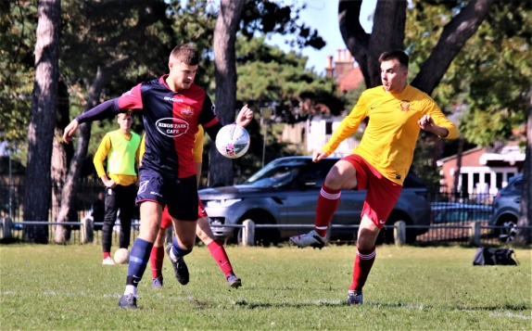
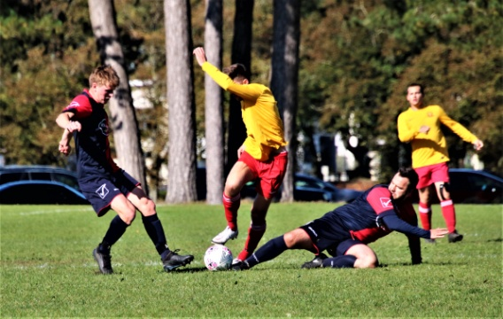

HAYWARD SATURDAY LEAGUE ROUND UP
Saturday 26th September 2020
MUDEFORD ARE EARLY DIVISION ONE LEADERS
Mudeford Mens Club lead DIVISION ONE of the HAYWARD SATURDAY LEAGUE on goal difference after Oliver Saunders, Harry Simon, and Liam Welton ensured a 3-1 success against West Howe who replied through Danny Hansford.
Winkton Athletic also have maximum points from their three games after their 3-1 victory over Twynham Rangers. Callum Zikmund struck twice for Winkton with Connor Mitchell adding the other one while Chris Forbes scored Twynham’s consolation goal.
The remaining games all finished with a 3-2 scoreline. Westover Bournemouth Reserves led with first half goals from Connor Picken and Karl Foster but Fordingbridge Turks stunned them ten minutes after the break, scoring twice in as many minutes through Finley Neale and Alex Marshall. The visitors went away with all three points when Marshall scored his second goal of the game from the penalty spot five minutes from time.
Bournemouth Manor Reserves just got the better of AFC Burton thanks to Paul Conroy, Dan Taylor, and substitute Liam Carpenter. Sam Nash and Barnaby Nicholls were the Burton marksmen.
Justin Keeler struck twice for New Milton Eagles but Royal Bournemouth had the edge thanks to Nile McKenzie, Kirsty Chorly, and Jordan Muir.

